Ion channels

- Allows ion to cross the membrane
- length 10 nm
- Many are highly selective ⟹ allow only a single type of ion to pass through
- Capacity of ions channels influences by
  - membrane potential
  - Internal concentration of various intracellular messengers
  - Extracellular concentration of neurotransmitters

- Ion pumps: transport ions against their concentration gradient, from low concentration area to high concentration area, to do so they need energy (ATP hydrolysis) ⟹ as an example the sodium potassium ionic pump moves 3 Na⁺ out and 2K⁺ ions in for each ATP molecule.

- Na⁺ and Cl⁻ more outside than inside
- K⁺ more inside than outside

- Na⁺ tends to depolarize cell (aka make inside more positive)
- Cl⁻ and K⁺ tends to hyperpolarize the cell (aka make inside more negative)

- Different channels evolve differently during time and determine behavior.
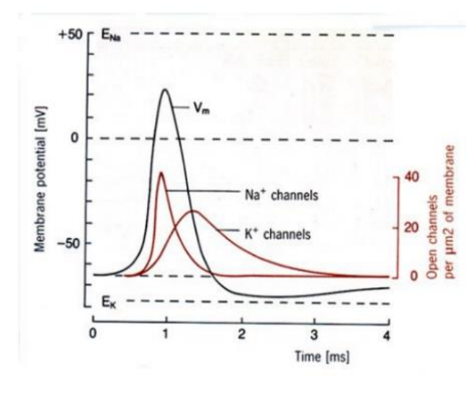
- At beginning Na⁺ fast opening ⟹ fast polarization, after a peak they start to close
- K⁺ open later than Na⁺ and reach peak later, close around 4ms

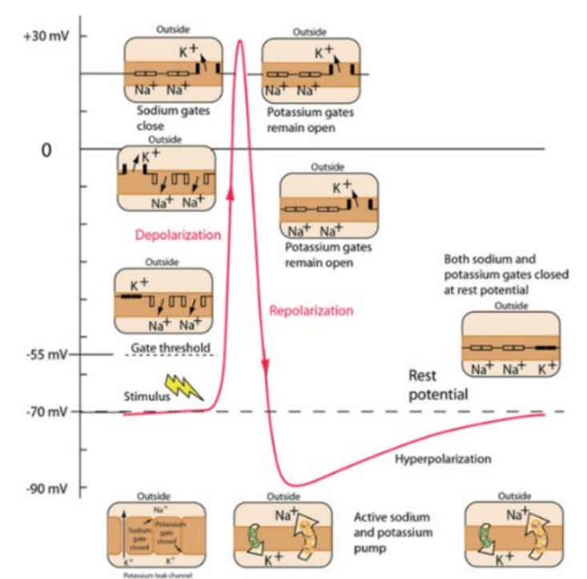

Voltage-gated Ion channels can be:
- Deactivated: closing after activation
- Activated: opening, voltage change
- Inactivated: flow of ions blocked by a mechanism other than closing of the channel (ball and chain model)

Membrane capacitance and membrane resistance
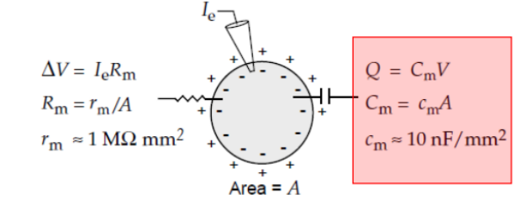

I = dQ/dt ⇐ current passing in the cell ⟹ how much current is required to change the membrane potential at a given rate.

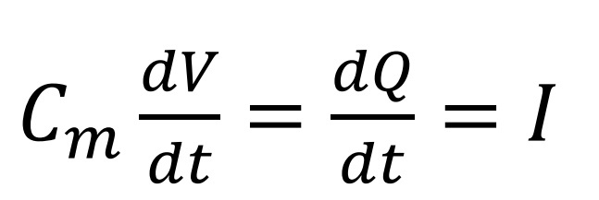

- Large cell ⟹ large capacitance C_{m}
- Small cell ⟹ small capacitance C_{m}
- But membrane capacitance per unit area c_{m} can be the same. C_{m} = c_{m} x 4πr²
- More charge (current I) is required to change the voltage V for a large cell.

- Ohm’s law: ΔV = I_{e}R_{m}
- R_{m} = r_{m}/A
- r_{m} more variable than c_{m}
- more channel ⟹ smaller R_{m}
- The resistance R is the slope of the relation between current I and voltage V

Membrane time constant 𝜏_{m}
- Membrane time constant: 𝜏_{m} = C_{m}R_{m} = c_{m}r_{m}.
- 𝜏_{m} is independent of the area
- It shows how V_{m} (membrane potential) does not change in time with area
- typically 10-100 ms
- smaller the time constant, more rapid will be the propagation of velocity

Length constant (space constant) λ
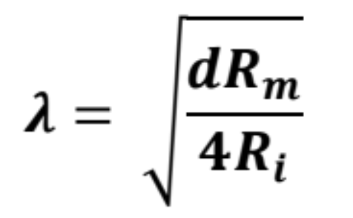

- Indicates how much V (voltage) is losing along traveling
- d: diameter of the axon
- R_{m}: resistance of membrane ⟹ if high it is insulated 🙂
- R_{i}: intracellular resistance ⟹ ability of charges to move along the inner surface of the axon ⟹ if high is worst 🙁
  - Higher for long and narrow stretches of dendrites or axon
  - Can cause substantial difference in the membrane potential measured in different parts of a neuron especially during action potential

Large λ:
- Voltage spread out more effectively along the membrane
- Depolarization effect of an input will spread out more along the neuron’s membrane
- More region will reach threshold needed to generate an action potential

Propagation velocity
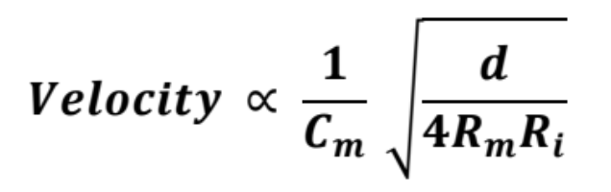

- Propagation velocity: is directly proportional to the space constant and inversely proportional to the time constant
- We can increase the propagation velocity by
  - Increasing diameter
  - Decreasing membrane capacitance
  - Increasing membrane resistance with myelin
    - Myelin is an insulating sheath
    - Cover the axon would cover voltage dependent Na channels ⟹ no spike 🙁
    - Cover only sections ⟹ called saltatory propagation and it maximizes the signal transmission

To sum total current (membrane), we have to sum two currents (channel ionic and capacitive), they have to sum because they are in parallel.
If current pass in:
- Channel ionic: V change instantaneously with I
- Resistive membrane: V changes linearly with I
- Both (parallel): V changes exponentially with a time constant RC

!Equilibrium (E) and Reversal Potentials (E)
- Na⁺ and Cl⁻ more outside than inside
- K⁺ more inside than outside

- Ionic pumps help to maintain the difference between external and inside
- Electric forces (difference between voltage inside and outside the membrane) and diffusion (high concentration vs low concentration) move ions inside and outside the cell membrane

- The equilibrium potential (E) is the potential at which current flow due to electric forces cancels the diffusive flow
- Boltzmann distribution exp(zqV/kBT) ⇐ probability that an ion with that charge cross the membrane
- Each ion have a different equilibrium potential (E_{K+} = -80mV, E_{Na+} = -67 mV, E_{Ca2+} 124 mV, …) when the equilibrium for a type of ion is reached then the neuron does not have any flow for that type of ion.
  - If E_{i} < E_{rest} ⟹ i will hyperpolarize the neuron
  - If E_{i} > E_{rest} ⟹ i will depolarize the neuron

[outside] = [inside]exp(zE/V) ⟹ Nernst equation: E = V_{T} / z ln( [outside] / [inside] )

- Equilibrium potential (E) is also called reversal potential (E) because the current flow switches as the membrane potential passes through E.
  - V>E ⟹ positive current flow out
  - V<E ⟹ positive current flow inward

Membrane resting potential E_{rest}
- E_{rest} = - 70 mV
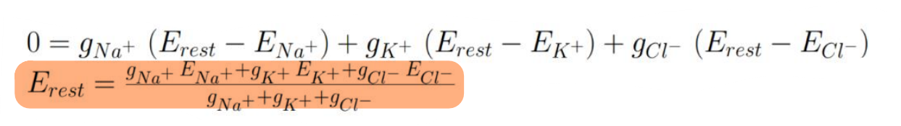

- The membrane resting potential it is reached when the total membrane current is 0 ⟹ aka no movement of charge across the membrane
- g in the formula is the inverse of the resistance (also called conductance)
- E_{rest} - E_{i} is called driving force and is the difference between the membrane resting potential and the ion equilibrium potential

Membrane current I_{m}
- The membrane current I_{m} represents the flow of ions across the neuron cell membrane thanks to a specific ion channel.
  - I_{m} is positive, by convention, when positive ions leave the neuron
  - I_{m} is negative, by convention, when positive ions enter the neuron
- Total membrane current is computed by summing all the membrane current of all the ions channels (including voltage dependent and synaptic channels)

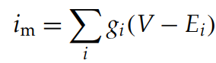
i_{m} is the membrane current per unit area: it is computed by summing across different specific conductance per unit area multiplied by the difference between the driving force (voltage minus equilibrium potential of ion i)

Leakage current: current that flows through the cell membrane via ion channels that are not gated (aka always open to some extent). The continuous flow of ions through the leakage channels contributes to a time-independent leakage conductance, aka the leakage channel provides a constant level of conductance that does not change over time.
- E_{L} (reversal potential associated to the leakage current) and g_{L} (leakage conductance) are treated as adjustable parameters in neuronal models.

Membrane Current: Refers to the flow of ions across the neuron's cell membrane due to the activity of all ion channels. It's a collective measure of ion flow resulting from all types of ion channels present in the neuron's membrane, including both voltage-gated and ligand-gated channels. This aggregate current reflects the combined influence of various ion species on the neuron's electrical state.

Specific Ion Channel Current: This is the current associated with a specific type of ion channel. Each type of ion channel (characterized by selectivity for particular ions, gating mechanisms, etc.) contributes to the overall membrane current based on its specific properties and the driving force across the membrane for its ions. The contribution of each specific ion channel to the total membrane current depends on factors like the channel's density, open probability, and the electrochemical gradient for the ion(s) it conducts.

Total Membrane Current: This is essentially the sum of the currents through all individual ion channels across the entire neuron's membrane. It is the net result of all ionic movements into and out of the neuron, factoring in every channel type's contribution. The total membrane current can be viewed as the macroscopic current that affects the neuron's membrane potential at any given time.

Properties of neurons
- Neurons are cells body able to probate signals rapidly over large distances
- Can propagate signals thanks to electrical pulses (aka action potentials or spikes) than travel down nerve fibers
- Actions potentials are the only form of membrane potential fluctuation that can propagate over large distances
- Neurons transmit information by firing sequences of spikes in temporal patterns
- Dendrites: receive inputs from other neurons
- Axon: carries the neuronal output to other cells. It terminates in synapses where voltage transient of the action potential opens ion channels releasing a neurotransmitter (a synapses can have a excitatory, depolarizing or inhibitory effect on the postsynaptic neuron)

Spike Trains and Firing rates

- Encoding: from stimulus to response
- Neural responses can vary even when the same stimulus is presented repeatedly
- We can not describe and predict the timing of each spike deterministically ⟹ use a model that accounts for the probabilities that different spikes sequences are evoked by a specific stimulus

Neural response ρ(t)
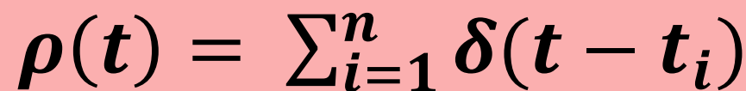
- Treat an action potential sequence by a list of times when spikes occurred
- δ is the dirac function ⟹ it is 0 everywhere except when its argument is 0 (aka when there is a spike)
- n: number of spikes
- t_{i} list of action potential times

- 🙁 the sequence of action potential generated by a stimulus varies from trial to trial, so we need to treat responses probabilistically

Spike-count rate r
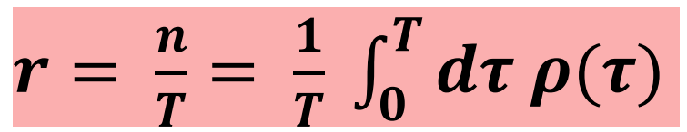

- Simplest firing rate
- The spike count rate r is obtained by counting the numbers of action potentials (spikes) appeared during a trial T and dividing by the duration of the trial T
- 🙁 using fixed bins the answer depends on where the boundaries are

Time-dependent firing rate r(t)

- Average number of spikes (over trials) appearing during a short interval between times t and t+Δt divided by the duration of the interval Δt
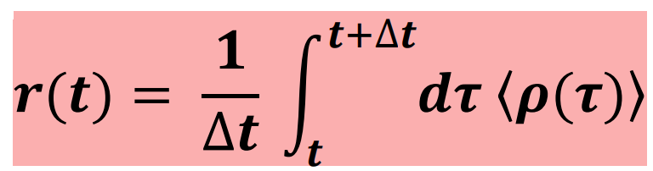
- 〈ρ(𝜏)〉 is the trial-averaged across multiple trials (divided by the number of trails)

Average firing rate 〈r(t)〉
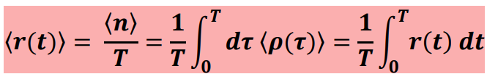

- Same of spike-count rate (r) but it is averaged over multiple trials

Measuring firing rates

- The firing rate can not be exactly determined from the limited data available from a finite number of trials
- There are different ways to approximate r(t) [time dependent firing rate] from a spike sequence

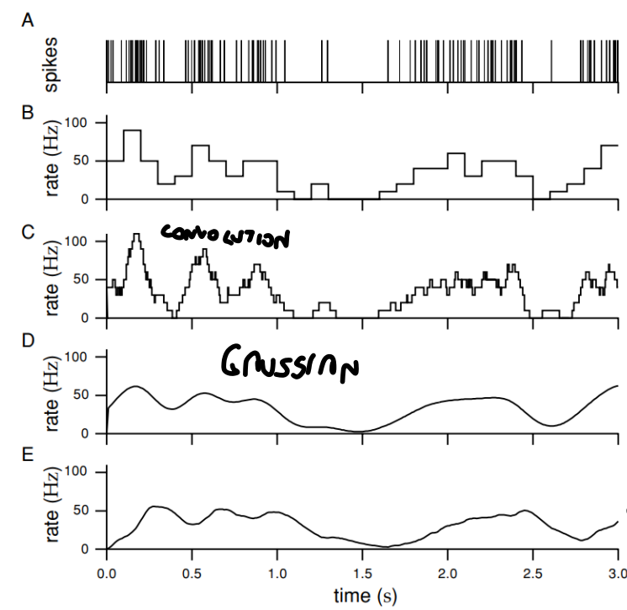
- Spike train recorded by a monkey watching a video



- Discrete-time firing rate obtained by binning time and continuing spikes with Δt = 100 ms
- Fixed bins and we convolve it
- Divide the number of spikes by Δt ⟹ Hz
- Decreasing Δt ⟹ increase temporal resolution



- Approximate firing rate determined by sliding a rectangular window function along a spike train with Δt = 100 ms
- The window is also called filter kernel (w)
- The issue with the convolutional window function is that it approximates the firing rate at any time using spikes fired both before and after that time. 🙁

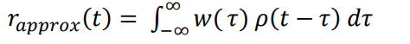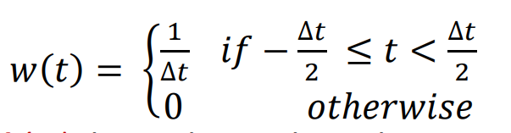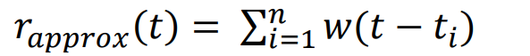

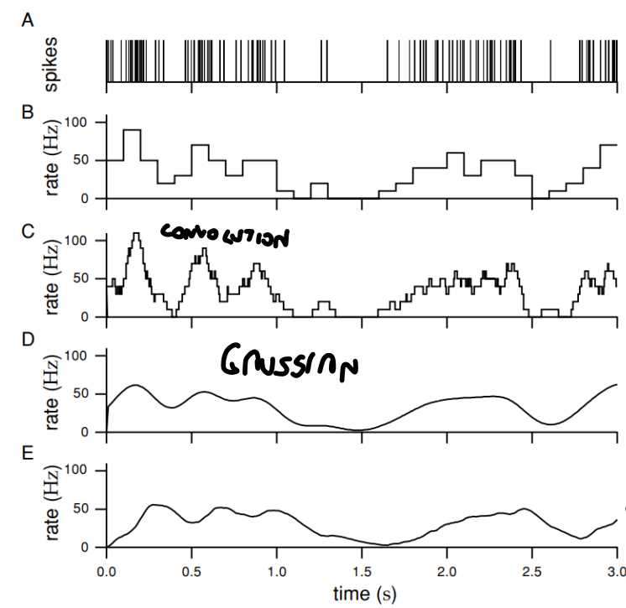

- Approximate firing rate computed using a gaussian window function of σ = 100 ms
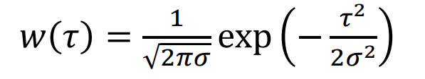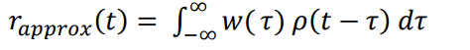

The issue with the gaussian window function is that it approximates the firing rate at any time using spikes fired both before and after that time. 🙁



- Approximate firing rate using α-function window with temporal resolution (1/α) = 100 ms
- Window function vanishes when its argument is negative
- Tends to peak later than the rate computed using temporally symmetric window functions

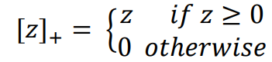
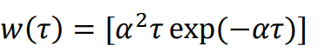

!Spike-triggered average C(𝜏)
- Ask: what on average did the stimulus do before an action potential was fired or what is the average stimulus that is responsible to trigger all the spikes that we have in the sequence
- neurons often respond most strongly to rapid changes in the stimulus properties and are relatively insensitive to steady-state levels
- Weber ⟹ measure how different the intensity of two stimuli had to be for them to be reliably discriminated, found out that Δs is proportional to the magnitude of the stimulus s ⟹ aka Δs/s is constant

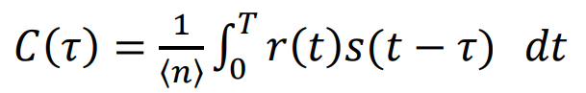
- Spike-triggered average stimulus C(𝜏) is the average value of the stimulus in a time interval 𝜏 before a spike is fired
- If n is large the total number of spikes for each trial is well approximated by the average number of spikes for trial
- Ask: every time this neuron fires what were the features of the stimulus that are responsible for making the neuron fires?
- Consider a time-window 𝜏 before the spike
- The response is typically affected only by the stimulus in a window a few milliseconds wide preceding a spike (sometimes there could be an overlap)

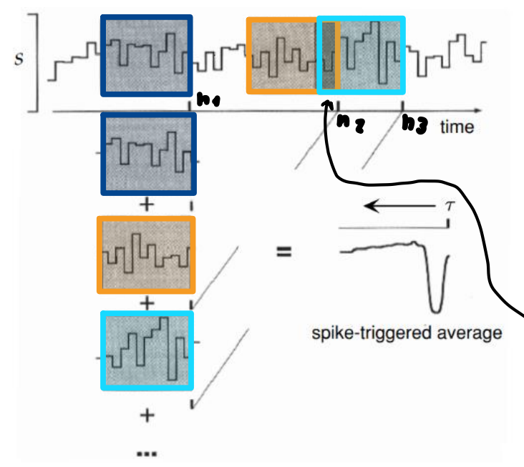

Also we can defined a correlation function Q_{rs}(𝜏) of the firing rate and the stimulus:
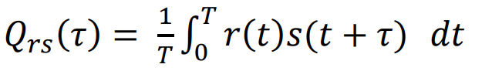
It measure how the firing rate (r) at any given time is related to the stimulus s value at time 𝜏 later

If we compare the correlation function with the spike triggered average we get:
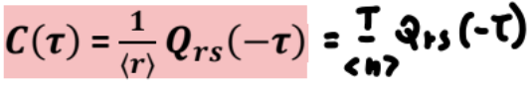
Where 〈r〉 is the average firing rate over the set of trials 〈r〉 = 〈n〉/T

!White noise stimuli
- A value of the white noise at any time is uncorrelated with its value at any other time (aka independent)
- A white noise stimuli fluctuate at all frequencies with equal weight (aka flat power spectrum). In theory, this means that white noise can cover all frequencies from the lowest to the highest imaginable.

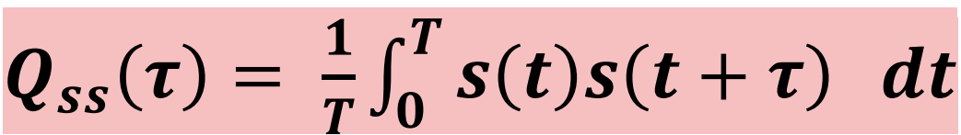
The stimulus-stimulus autocorrelation function shows the correlation of the stimulus over time by comparing a stimulus at time t and a stimulus at time t + Δt.
- For white noise stimuli: the stimulus-stimulus autocorrelation function is equal to 0 at any point (because no correlation) except when 𝜏 = 0, In this case the value is σ²_{s} (variance of the stimulus)

- No physical system can generate noise that is white to arbitrarily high frequencies, this is a practical limitation of real world systems, in theory white noise contains all frequencies up to infinity, however in practice it is impossible to do physical and technical limitations.
- ⟹ we approximate white noise stimuli by using integer multiples of a basic unit of duration Δt and we form a discrete sequences of stimulus values. We consider a discrete form of autocorrelation.
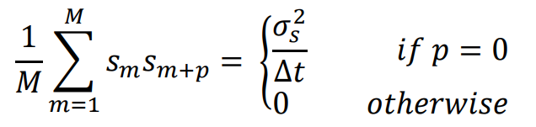
- We choose each stimulus s_{m} from a certain probability distribution with mean 0 and variance σ²_{s}/Δt
- If this probability is a Gaussian function, we have a Gaussian White Noise
- We use correlation function (discrete) if we want to simulate a neuron with dynamic stimulus of white noise type. We need discrete steps.

Spike-train statistics
- Spike times are continuous variables ⟹ the probability for a spike to occur at any precisely specified time is actually zero
- To get a nonzero value we have to ask what if the probability that a spike occurs within a specified interval Δt
- We use some models that allows to estimate the probability of an arbitrary spike sequence occurring

- If spikes are considered independent, the probability of a sequence of spikes can be computed as the product of the probabilities of individual spikes. This makes it possible to estimate the likelihood of spike sequences without considering the combinatorial complexity of all possible spike interactions.

There are three different types of stochastic process
- Point process: stochastic process that generates a sequence of events
- Renewal process: probability of an event occurring at any given time depends on the immediately preceding event
- Poisson process: no dependency at all on preceding events
  - Homogeneous poisson process: statistically independent event + independent of time
  - Inhomogeneous poisson process: statistically independent event + dependent on time

Homogeneous Poisson process
- Statistically independent event + independent of time
- The firing rate (frequency, Hz) is constant over time ⟹ r(t) = r

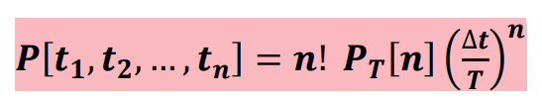
Formula for generate a sequence of n spikes over a fixed interval T with equal probability

- P[t₁, t₂, … , t_{n}] probability of a certain time of each spike
- n! how many spikes there are in the sequence
- P_{T}[n] probability that an arbitrary sequence of exactly n spikes occurs within a trial of duration T. It depends on
  - (rΔt)^{n} Probability that a spike occurring in one specific bin
  - (1 - rΔt)^{M-n} Probability of not generating spikes in the other bins
  - M! / (M - n)!n! Combinatorial factor of the number of ways of putting n pikes into M - n bins
- Δt / T size of the bin Δt divided by the total duration T
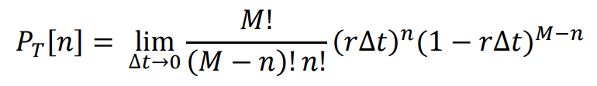

That we can rewrite P_{T}[n] as a Poisson distribution:
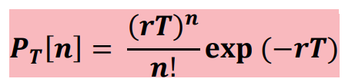
Formula: probability of observing exactly n events (spikes) in an interval T given a constant average rate r. ⟹ how likely it is to observe a certain number of events based on the average rate at which they occur
- As n increases the probability reaches its maximum at large T values.
- For large rT the Poisson Distribution approaches to the Gaussian distribution

Fano Factor F = σ²_{n} / 〈n〉
- The Fano factor is the ratio between variance and mean of the spike count
- F = σ²_{n} / 〈n〉
- The Fano factor (F) measures the dispersion of a continuing process
- With Poisson process spikes occurs at random + probability of a spike to occur in any given interval is the same ⟹ F = 1 ⟹ dispersion of the spike is random process with no variability or regularity
- With a constant interval between spikes (holding times) ⟹ F = 0 ⟹ renewal process where each spike is perfectly predictable

Interspike interval distribution
- Interspike interval: period of time between two consecutive neuronal spikes. Measure the time from one peak of one spike to the next
- Interspike interval distribution: statistical measure that describes the probabilities of different interspike interval occurring within a spike train

Probability that an interspike interval falls between 𝜏 and 𝜏 + Δt for a homogeneous Poisson process

- If a spike occurs at time t_{i}, the probability of the next spike to occur in a small window of time between t and t + Δt is given by the probability that no spike occur up to time t exp(-rt) multiplied by the probability of a spike occurring in a small interval Δt, that is rΔt
- In homogeneous poisson process the interspike interval distribution is exponential rexp(-rt) because of the memoryless property of the Poisson process (each spike is independent of the last), so shorter interval between spikes are more likely to occur than longer ones

In a homogeneous Poisson process
- Mean interspike interval 〈t〉= 1/r ⟹ is the average time between spikes
- Variance interspike interval σ²_{n} = 1 / r²
- Coefficient of variation C_{v} = σ_{t} / 〈r〉 ⟹ in a homogenous process is equal to 1.

Spike-train autocorrelation function
- Spike-train autocorrelation function: determine the distribution of times between any two spikes in a train
- Used to detect patterns in spike trains (most notably oscillations)
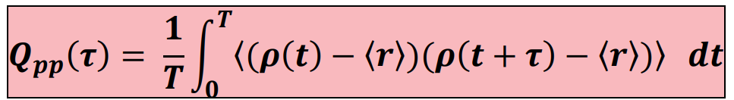

- It is the product of the deviation of the spike train from its mean rate at two points in time separated by 𝜏 and then averaging this product over time.

- N_{m} count of pairs of spikes that are a certain distance apart in time. Count spikes pairs that are separated by a time interval that falls between (m - 1/2)Δt and (m + 1/2)Δt where Δt is the width of the bin
- For small bin size we have m = 0 (m is the bin for the shortest interval) starts to count how many spikes occur at nearly the same time, if you make Δt smaller and smaller this count approach zero because it becomes less likely that two spikes will be indistinguishably close together in time.
- H₀ = 〈n〉/T that is the average firing rate 〈r〉
- Q_{pp}(𝜏) tells you how the spikes correlated with themselves over time. For a Poisson process we have: Q_{pp}(𝜏) = rδ(𝜏) where δ(𝜏) is the Dirac delta function, this means that in a Poisson process spikes are only correlated with themselves at 𝜏 = 0, and there is no correlation at any other interval

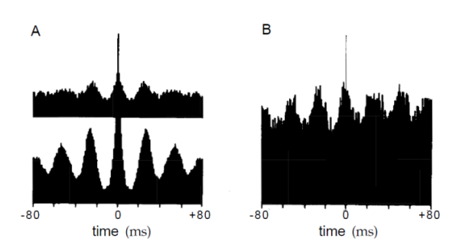

Panel A:
- Autocorrelation for neurons recorded in right and left hemispheres of the visual cortex of a cat
- Autocorrelation histograms are used to measure how the firing of a single neuron at one time point is related to its firing at another time point
- Peaks of the firing rate have a regular oscillatory pattern, spikes occurring at about 40 Hz
- Peaks show the strength of the oscillation. Lower diagram have higher peaks ⟹ stronger oscillations in left hemisphere (bottom A) compared to the right hemisphere (top A)
Panel B:
- Cross correlation between neurons of the left and right hemisphere.
- Cross correlation histogram are similar to autocorrelation histogram, but instead of comparing a neuron to itself at different times it compared the firing rate of one neuron to the firing rate of another neuron
- it show the oscillations in the two hemispheres are synchronized with little time delay ⟹ neurons fire in a rhythmic pattern that is aligned across both hemispheres

Inhomogeneous Poisson Process
- Statistically independent event + time dependent
- The firing rate r(t) is not-constant and depends on time, but the spikes are still generated independently

Poisson Spike generation: algorithm
- Generate a random number x_{rand} between 0 and 1
- If r(t)Δt > x_{rand} ⟹ spike fired
- If r(t)Δt < x_{rand} ⟹ spike not fired
- ⟹ higher r(t) ⟹ more likely to generate a spike
- ⟹ this model is not deterministic since x_{rand} is random
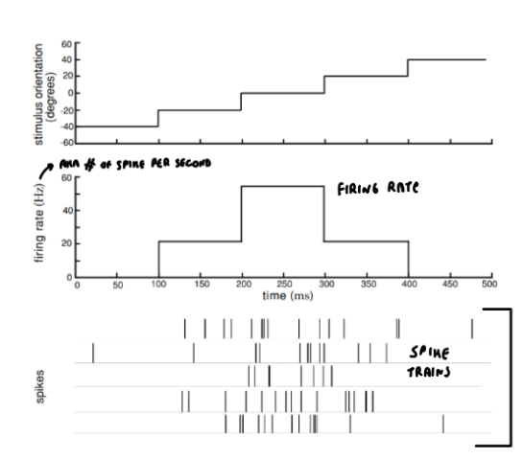
- Stimulus parameter: orientation degree along time
- We know the tuning curve (it show the firing rate of a neuron in response to a stimulus, aka the orientation)
- We obtain the firing rate ⟹ depends on the stimulus and on the tuning curve
- Poisson process applied to generate 5 sequences (trials) of spikes. Obtain 5 possible responses that correspond to the that firing rate

Evaluation of Poisson model
- Is a simple and useful
- We need to understand if this model match data on real neural response variability
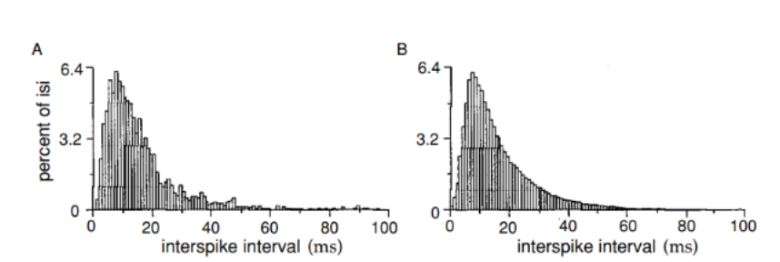

- A: interspike interval distribution from an MT neuron responding to a moving, random-dot image.
- B: interspike interval histogram generated from a Poisson model with a stochastic refractory period (refractory period: short time in which a neuron is less likely to fire again)
- For interspike interval longer than 10 ms the histogram is exponential, a characteristic of the Poisson process
- For shorter interval (less than 10 ms) add a refractory period of variable duration (mean = 5 ms, std = 2 ms) ⟹ shorter interval less likely than the prediction of a standard Poisson model.

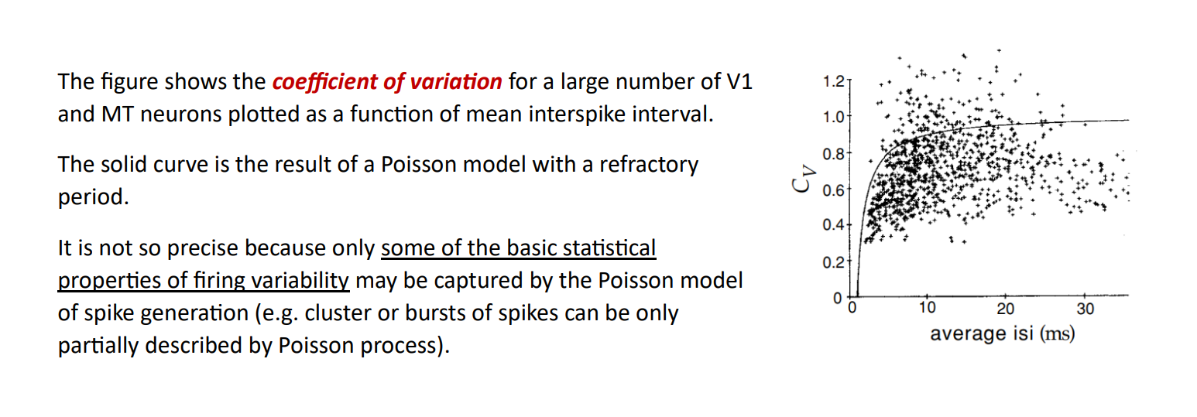
- Coefficient of variation (C_{V}) of interspike intervals vs average interspike interval for a population of V1 and MT neurons
- C_{V} = σ_{t}/〈r〉: ratio between standard deviation of interspike interval and mean of interspike interval.
- Average ISI: average time between spikes
- Solid line: expected relationship according to Poisson model with a refractory period
- The Poisson model is not so precise, only some basic statistical property of firing variability are captured 🙁

Estimating firing rate
- Spike-triggered averages and reverse-correlation are techniques used to construct estimate of the firing rates evoked by arbitrary time-dependent stimuli

- Spike triggered averaging:
  - Tool that characterize the response property of a neuron using the spikes emitted in response to a time-varying stimulus. Provides estimate of neuron’s linear receptive field (selectivity of the neuron)
  - Average signal taken at the times of spike occurrences and with proper normalization is equivalent to the cross-correlation between the continuous signal and the spike train
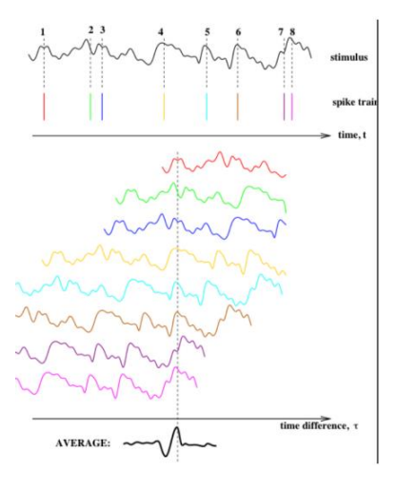
- Record the stimulus over a complete spike train
- Record all spike times
- For every spike add the stimulus values surrounding the spike into the spike-triggered average array
- Divide by the number of spikes to get spike-triggered average

- Reverse correlation:
  - Activity of a neuron depends on the behavior of the stimulus over a period starting 100 ms before t and ending 10 ms before t.

  - Determine temporal and spatial structure of a neuron’s receptive field based on the stimuli that vary randomly in time
  - Used to construct a more accurate model
  - Estimate the response (firing rate) r_{est}(t)
  - Assume that the firing rate is equal to the weighted sum of the values taken by the stimulus at earlier times
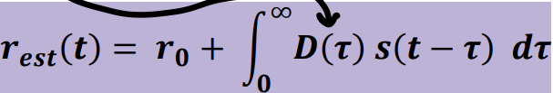

- r_{est}(t): estimate of the firing rate r(t) evoked by a stimulus s(t)
- r₀: background when s = 0
- D(𝜏): linear filter (kernel) weighing factor that determines how strongly the stimulus at time t-𝜏 affects the firing rate at time t

The optimal D (kernel) is chosen to minimize the difference between estimated response to a stimulus r_{est}(t) and the actual measured response averaged r(t) over the duration of the trial T. Minimize the error function E:

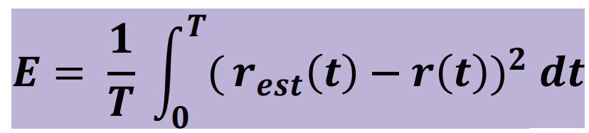

- The standard method used to determine the optimal kernel is to measure the spike-triggered average stimulus in response to white-noise stimulus
- This method works well when the stimulus changes slowly
- Issue: method fails to capture high-frequency fluctuations because the linear kernel D is based on white-noise stimulus and no system at high frequencies behaves as a white noise stimulus

Static nonlinearities
- Other issues:
  - nothing to prevent the predicted firing rate to become negative
  - the predicted rate does not saturate, it increases without bound as the magnitude of the stimulus increases

- Solution: r_{est} is the sum of a background rate r₀ and the nonlinear function (F) of the linearly filtered stimulus (L(t))
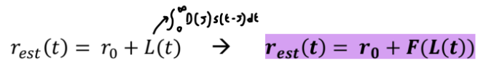
- F is an arbitrary function called static nonlinearity.
- Static nonlinearities are used to introduce both firing threshold and saturation into estimates of neural responses

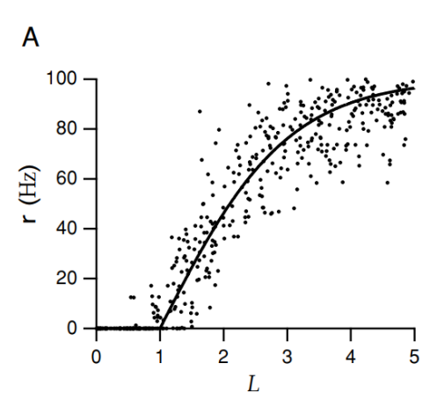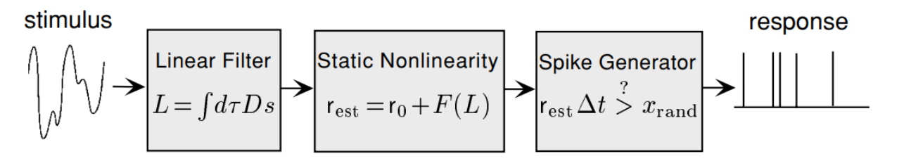

- Stimulus: external signal or input that the neuron receives
- Linear filter: convolution of the stimulus s with the neuron’s receptive field. Integrate the stimulus over time with the weighted receptive field D which describes how different time points of the stimulus contribute to the neuron’s output
- Static nonlinearity: introduce nonlinearity to the model. F is a nonlinear function that transforms the filtered stimulus L. This accounts to the fact that the relationship between the input and the firing rate is not perfectly linear
- Spike generator: this component models the actual generation of the spike. Use a probabilistic event. Generate a random number x_{rand} between 0 and 1
  - If r_{est}Δt > x_{rand} ⟹ spike fired
  - If r_{est}Δt < x_{rand} ⟹ spike not fired
  - ⟹ higher r_{est} ⟹ more likely to generate a spike
  - ⟹ this model is not deterministic since x_{rand} is random

With those steps from the stimulus once we know the kernel D we can estimate the spike responses.

!Visual system
- In the retina light is converted into electrical signals when strikes photoreceptors cells
- It is possible to observe the electrical activity in these cell by inserting microelectrodes to measure the changes in electrical potential across the cell’s membrane
- Rods: more sensible to light, responsible for vision in low-light conditions
- When exposed to light rods cell on left side are hyperpolarized ⟹ become more negative inside compared to the outside
- The hyperpolarized signal from the rods is transmitted to other cells in the retina (bipolar and horizontal cells)
- In bipolar cells the signal undergoes an inversion, switch from hyperpolarization to depolarization ⟹ if reach a threshold it will trigger an action potential

- Retinal Ganglion Cells (RGC) are the output neurons of the retina. They carry visual information to the brain
- Retina Ganglion Cells can be classified based on their response to light
  - G1: fires when the light is turned off
  - G2: fire when light is turned on

- Receptive field of a neuron: specific area of the visual field where a stimulus will affect the firing of that neuron
- In the receptive field different regions will respond differently to illuminations. Some areas will increase the neuron’s firing rate when illuminated (on regions), while others will increase firing when they are in the dark (off regions)
- Receptive field consist of two main components:
  - Overall region of the visual field affecting the neuron’s firing
  - Spatial and temporal structure within this region which determines how the neuron respond to visual stimuli over time and space

Classification of neurons based on their response to stimuli within their receptive fields
- Simple cells: allow linearity in their responses, linear relationships between stimulus and response
- Complex cells: no linearity, relationship between stimulus and responses is more complicated

- neurons might be selective for various visual features such as light spots, dark bars, edges between light and dark regions, …
- The receptive field is represented by the kernel, which is a model that correlates the stimulus with the neuron’s response
- Shape of the kernel indicate the type of features the neuron is responsive to

Reverse correlation methods
- Spike triggered average for visual stimuli: average over trials of stimuli evaluated at 𝑡_{𝑖} − 𝜏 (𝑡_{𝑖} spike times).
- Light intensity of visual image depends on location (x,y) and time (𝜏)
- ⟹ Spike triggered average stimulus: function of three variables 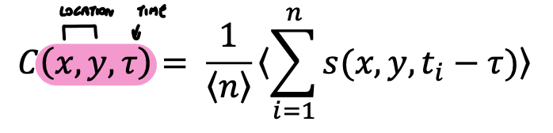
- (Stimulus-response) Correlation function between firing rate at t and stimulus at t + 𝜏, for trials of duration T:
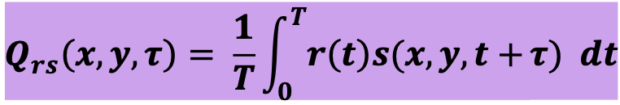
- Spike triggered average related to reverse-correlation function: 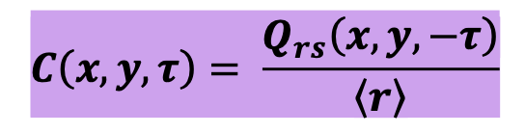
- 〈r〉 = 〈n〉/T average firing rate over entire trial
- Kernel = spike triggered average to estimate firing rate 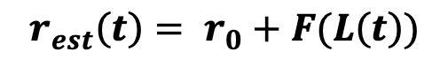
- Linear estimate L(t) obtained by integrating over past history of stimuli with a kernel acting as weighting function.
- Kernel 𝐷(𝑥, 𝑦, 𝜏) determines how strongly and with what sign visual stimulus at point (x, y) and at t - 𝜏 affects firing rate of neuron at t → space time receptive field 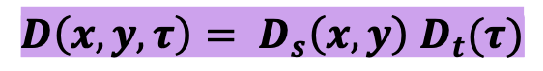
- Product of two functions, possible to separate space-time receptive field because spatial structure of receptive field changes over time just only for a multiplicative factor
- 𝑫𝒔(𝒙, 𝒚) spatial receptive field
- 𝑫𝒕(𝝉) temporal receptive field

Spatial receptive field 𝑫_{𝒔}(𝒙, 𝒚)
- Spatial receptive field of simple cells in cat primary visual cortex by averaging stimuli between 50 ms and 100 ms prior to an action potential.
- There are some regions where 𝐷𝑠 is positive (ON) and others negative (OFF)
- Response enhanced: ON regions are illuminated (s>0) or OFF regions are darkened (s<0).
- Response suppressed: ON regions darkened, OFF regions are illuminated.

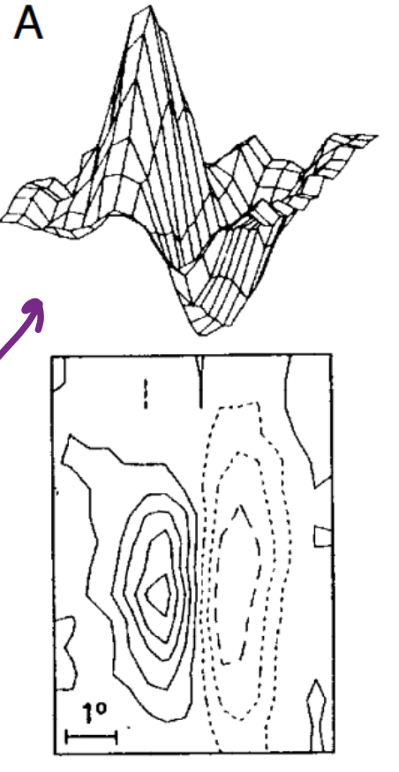

- Upper plot: 3D representation with x.y plane on horizontal and vertical dimension show the magnitude of D_{s}(x,y) (aka how much the stimulus in that specific point is affecting the occurrence of the spike)
- Lower plot: x-y plane. Regions with solid contour curves are ON areas D_{s}(x,y) > 0 and dashed regions are OFF areas D_{s}(x,y) < 0

Temporal receptive field 𝑫_{𝒕}(𝝉)
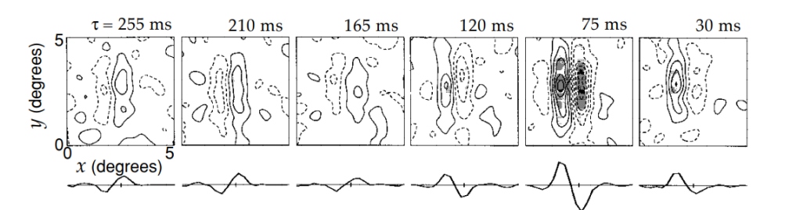

- Temporal evolution of a spatial receptive field
- More than 300 ms prior to a spike there is little correlation between visual stimulus and upcoming spike
- 210 ms two lobed OFF-ON receptive field
- As 𝜏 decreases the structures fades away and then reverses
- 75 ms the receptive field have an opposite sign
- ⟹ the stimulus preferred by this cell is an appropriately aligned dark-light boundary that reverses to a light-dark boundary over time.

- Constructing V1 Receptive Fields
- Hubel & Wiesel (1962) proposed that the oriented receptive fields of cortical neurons could be generated by summing the input from appropriately selected LGN neurons.
- Hubel-Wiesel Models
- Hubel & Wiesel proposed two models: one for a simple and one for a complex cell:
- 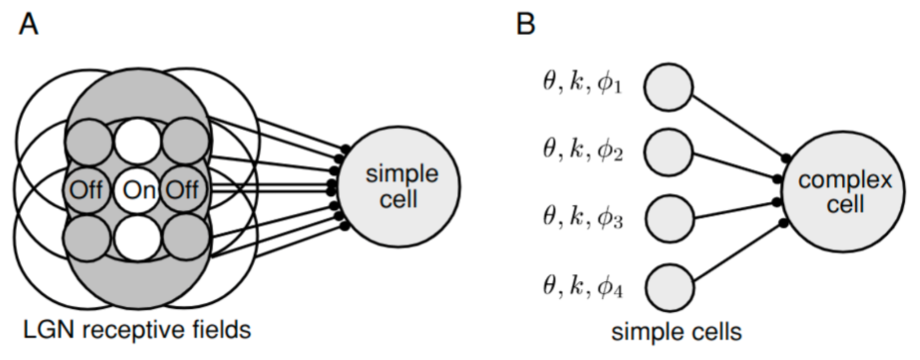
- model of orientation selectivity (A): in this model for a simple cell, the spatial arrangement of the receptive fields of nine LGN neurons are shown, with a row of three ON-center fields flanked on either side by rows of three OFF-center fields. White areas denote ON fields and gray areas, OFF fields. This arrangement produces a receptive field oriented in the vertical direction.
- model of a complex cell (B): in this model, a phase-invariant response of a complex cell is produced by summing together the responses of several simple cells with similar orientation and spatial frequency tuning, but different preferred spatial phases. This produces a complex cell output that is selective for orientation and spatial frequency, but not for spatial phase.

Decoding
- Decoding: estimate information content of neuronal spike trains
- Involve both single neurons and neuronal populations
- Neural responses are typically described by stochastic models due to their inherent variability
- Stimuli are often described stochastically
- ⟹ use Bayes theorem

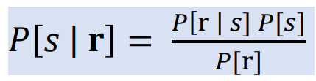
The probability to recognise the stimulus s(t) given a specific spike train r
- Increase with the probability that a specific r exists cause by s(t)
- Increase with the probability that stimulus s(t) occurs
- Decreases with the probability r occurs independently from s(t)

- For decoding response we need to determine prob P[s|r]
- Stimulus and response characterized by discrete values ⟹ ordinary probabilities
- Response firing rate or stimulus values as continuous variables ⟹ probabilities densities
- Bayes theorem defines prob that a certain neuron recognizes a stimulus among a certain distribution of possible stimuli.

Population decoding
- Use a large number of neurons to represent information
- In population decoding individual neurons typically have different but overlapping selectivies, many neurons respond to a given stimulus
- Advantages:
  - Reduction of uncertainty due to neuronal variability
  - Ability to represent a number of different stimulus attributes simultaneously
  - Response of a population of neurons can also be used for discrimination

Encoding and Decoding Direction (cercal system of cricket)
- Detect the direction of incoming air currents as a warning of predators
- Small number of neurons
- Cerci covered by hairs, Each hair is attached to a neuron that fires when the hair is deflected
- Thousands of these primary sensory neurons send axons to a set of interneurons that rely on the sensory information to the rest of the cricket’s nervous systems

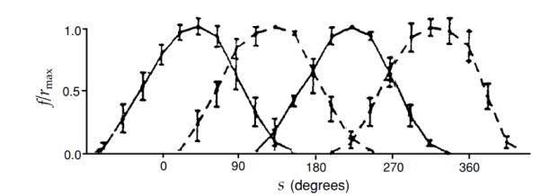
- Tuning curves for 4 low velocity interneurons of the cricket cercal systems. Preferred directions of the neurons are located 90’ from each other
- r_{max} typically around 40 Hz
- Interneuron tuning curve can be approximated to half wave rectified cosine function

Optimal decoding methods
- Two methods to reconstruct a stimulus from the firing rate of a population of neurons
  - Bayesian Inference
  - Maximum a Posteriori Inference
- They use conditional probability that a stimulus parameter takes value between s and s + 𝛥𝑠, given set of N encoding neurons fired at rates given by r
- 𝑝[𝑠|𝐫] = 𝑝[𝐫|𝑠]𝑝[𝑠] 𝑝[𝐫] (prob density)

Bayesian inference:
- Based on minimization of particular loss function 𝑳(𝒔, 𝒔_{𝒃𝒂𝒚𝒆𝒔}) that quantifies cost of reporting estimate 𝒔_{𝒃𝒂𝒚𝒆𝒔} when correct answer is s.
- Values of 𝒔_{𝒃𝒂𝒚𝒆𝒔} chosen to minimize expected loss averaged over all stimuli for given set of rates, to minimize function ∫ 𝑳(𝒔, 𝒔_{𝒃𝒂𝒚𝒆𝒔}) 𝒑[𝒔|𝒓] 𝒅𝒔.
- If loss function 𝐿(𝑠, 𝑠_{𝑏𝑎𝑦𝑒𝑠}) = (𝑠, 𝑠_{𝑏𝑎𝑦𝑒𝑠})² then estimate that minimizes expected loss is 𝒔_{𝒃𝒂𝒚𝒆𝒔} = ∫ 𝒑[𝒔|𝒓] 𝒔 𝒅𝒔.

Maximum a Posteriori Inference:
- Simply chooses the stimulus value 𝑠𝑀𝐴𝑃 that maximizes conditional probability density of stimulus 𝒑[𝒔𝑴𝑨𝑷, |𝐫].
- If prior of stimulus probability density p[s] is independent of s, MAP algorithm is equivalent to maximizing likelihood function, choosing 𝑠𝑀𝐿 to maximize 𝑝[𝐫|𝑠𝑀𝐿].

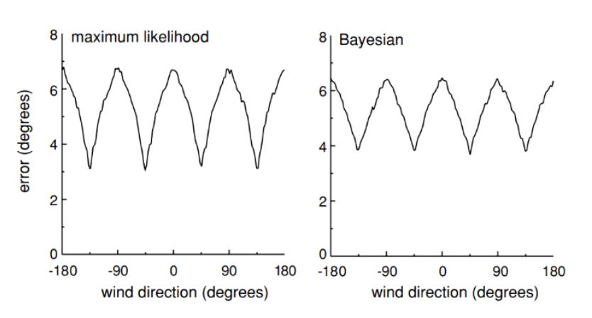
- Shows root mean squared difference (error) between true (s) and estimated (s_{est}) wind direction for cercal system, using ML and Bayesian method.
- Both estimates use constant stimulus prob density 𝑝[𝑠] independent of s. (Estimates are identical)

(boh) Spike-train decoding
- Traditional decoding methods estimate status stimulus values, which do not change over time
- However, spike-count firing rate are not adequate for decoding stimuli that change over time

- Spike train decoding: estimate the stimulus at a specific time point by analyzing the sequence of spike sup to that time
- +Use a time-window (kernel)
- Use past spikes to predict the current value of the stimulus
- Use a prediction delay 𝜏₀ which means that the estimate of the stimulus at time t is based on spikes that occurred before time t - 𝜏₀

!Mutual information I_{m} = H - H_{noise}
- While entropy is a measure of the theoretical capacity of a code to convey information, mutual information measures how much of that capacity is actually used when the code is employed.
- Entropy based-measure.
- Neurons can provide information about stimulus only if its response variability is correlated with changes in that stimulus.
- To determine whether response variability correlated with stimulus variability → compare responses obtained using different stimulus on every trial with those measured in trials involving repeated presentations of same stimulus:
- Response informative: larger variability for trials involving different stimuli.
- Response not informative: larger variability for trials involving same stimuli.
- Mutual information 𝑰𝒎 difference between total response entropy and average response entropy (“noise”) on trials with repeated same stimulus (contribution from response variability not associated with identity of stimulus)
- Entropy of responses evoked by repeated stimulus s computed using 𝑃[𝑟|𝑠] 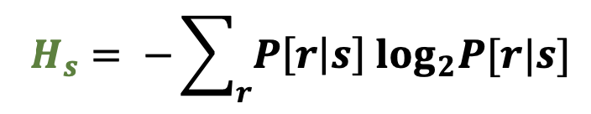
- Averaging all stimuli we obtain entropy that is not associated with part of response variability not due to changes in stimulus, but arises from other sources (intrinsic variability of neural response): 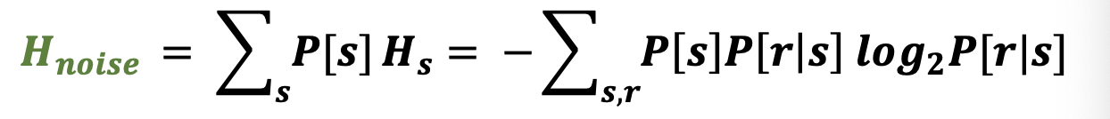
- Mutual information:
- 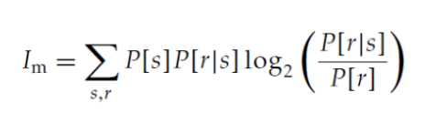
- Examples
- Responses of neuron are completely unaffected by stimulus. Prob given a certain stimulus, it is probability of response itself because not affected by response (𝑷[𝒓|𝒔] = 𝑷[𝒓]) and follows 𝑰𝒎 = 0. → response is not telling nothing wrt environmental stimulus, because response not evoked by stimulus itself
- Each stimulus s produces unique 𝒓𝒔. One to one mapping stimulus response 𝑷[𝒓𝒔] = 𝑷[𝒔]. Thus conditional prob of response given specific associated stimulus is 1 𝑷[𝒓|𝒔] = 𝟏 if 𝑟 = 𝑟 , 0 otherwise.
Represents entropy of stimulus, so no variability and a one-to-one map from stimulus to response, mutual information equal to full stimulus entropy.
- Two possible stimulus values (+ and -), neuron responds with just two rates 𝒓+ and 𝒓−. Associating two rates with two corresponding stimulus, in this case encoding not perfect (prob of incorrect response Px)
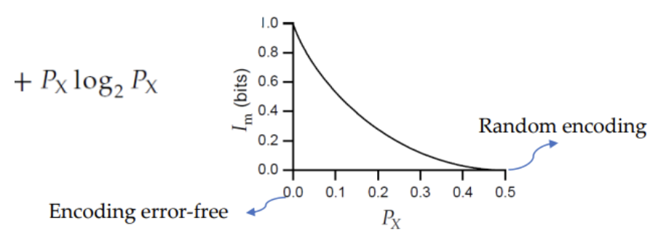

love u

Entropy and Mutual information for continuous variables
- Prob of firing rate lying in range r and r + ∆𝑟. For small ∆𝑟, expressed in terms of prob density 𝒑[𝒓] ∆𝒓:
- ∆𝒓: size of discrete bins. Response expressed in terms of interspike interval.
- Continuous variable measured with perfect accuracy has infinite entropy (∆𝑟 → 0, 𝑙𝑜𝑔2∆𝑟 term diverges, and entropy becomes huge).
- We can write limit:
- ∆𝑟: best solution of a limit on resolution with which firing rate can be measured.
- Unless limit known, entropy of a prob density for continuous variable can be determined only up to an additive constant (log2 ∆𝑟).
- Differential entropy: if two entropies computed with same resolution are subtracted, troublesome term involving ∆𝑟 cancels:

Entropy maximization for single neuron
- Are neural responses to natural stimuli optimized to convey as much info as possible?
- Computing response characteristics that maximize mutual information. If noise entropy is small, maximizing response entropy involves maximizing mutual information.
- To maximize response entropy, find a prob density 𝑝[𝑟] that makes integral 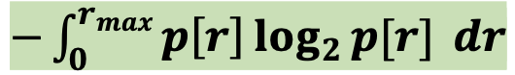as large as possible.
- Constraints: ∆𝑟 fixes and log2∆𝑟 constant and can be ignored;
- 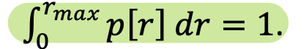
- For entropy maximizing condition, example of LMC in visual cortex of fly.

Entropy maximization for populations of neurons
- Entropy maximization for a population requires that the neurons convey independent pieces of information

- Entropy for the entire population responses
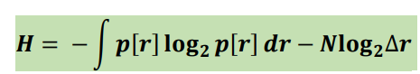

- Entropy associated with individual neurons:

- H ≤ ∑_{a} H_{a} ⇐ the true population entropy can never be greater than the sum of these individual neuron entropies over the entire population. If neurons are perfectly independent the total entropy is exactly equal to the summation of the entropy of single neurons. If there is any correlation there is some overlaps about the information that they are carrying on.
- If ∑_{a} H_{a} - H = 0 ⟹ no redundancy, all neurons are decoding something that is independent regardless of the others
- If ∑_{a} H_{a} - H ≠ 0 ⟹ some correlation in the response

Entropy and information for spike trains
- Computing entropy or information content of neuronal response characterized by spike times difficult, but these computations important, because firing rates are incomplete descriptions that can lead to serious underestimates of entropy and information
- The entropy or mutual information typically grows linearly with the length of the spike train
- Entropy (or information) rate H* ⟹ either H/T (bits per second) or H/T<r> (bits per spike)
- H* indicates maximum velocity at which the spike trains convey information about environmental stimuli/events
- To compute these rates, need to determine probabilities that various temporal patterns of AP appear (individual spikes times or sequence of interspike intervals)
- Prob of interspike intervals are statistically independent, entropy associated with interspike intervals in spike train of average rate <r> and duration T is:
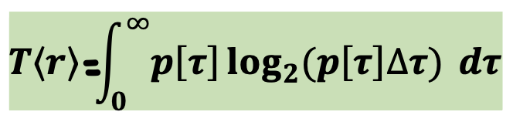
- correlations between different interspike intervals reduce total entropy, so result obtained by assuming independent intervals provides upper bound on true entropy of a spike train:

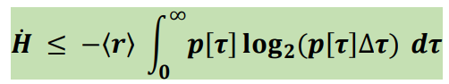
- If spike train des ribbed by Homogeneous Poisson process with rate <r> we have 𝑝[𝜏] =〈𝑟〉 exp(−〈𝑟〉𝜏) and interspikes are statistically independent:
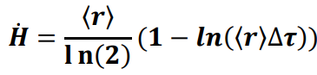

Single compartment model
- Single compartment model: model that describe the membrane potential of a neuron by a single variable V
- Equation describe how charges flow into and out of a neuron and affects its membrane potential

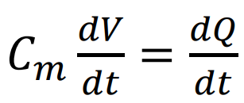
- The equation show how the membrane potential changes over time
- This equation states that rate of change of membrane potential is proportional to rate at which charge builds up inside the cell.

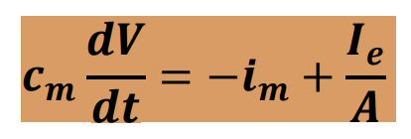
- i_{m} is the membrane current per unit area
- I_{e} is electrode current
- A is the surface area of the neuron
- The rate of charge buildup is equal to the total amount of current entering the neuron (including those arising from all the membrane and synaptic conductances plus any current injected into the cell through an electrode)

Spike-train adaptation of integrate-and-fire models
- Integration of the integrate-and-fire model modified to incorporate more complex dynamics
- We consider the adaptation frequency (since is not possible that the spikes are generated with the same frequency every time, we need some adaptations)

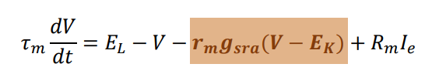

- The new element slow down the frequency, it makes more difficult to reach a threshold
  - Spike-rate adaptation conductance g_{sra}
  - Driving force V-E_{K} (for potassium K⁺ conductance)

- Whenever a neuron fire spike g_{rsa} is increased by an amount Δg_{rsa}
- There is a good match between real model and the experimental described by the integrate and fire model

Refractoriness
- Besides the spike-rate adaptation we want to incorporate also the refractoriness
- Because the probability that a neuron fires is significantly reduce for a short period of time after the appearance of an action potential
- ⟹ we need to introduce a refractory period like this in the integrate and fire model
- Possible solutions:
  - Do this by adding a condition to the basic threshold crossing rule that forbids firing for a period of time immediately after a spike
  - Or add a conductance similar to the spike-rate adaptation conductance with faster recovery time and a larger conductance increment following an action potential. With a large increment, the current can block the neuron to E_{K} temporarily preventing further firing (absolute refractory period), when conductance relaxes back to 0 we have a relative refractory period
  - Raise threshold for an action potential generation following a spike and then allow it to relax back to its normal value

voltage-dependent conductances
- Most properties from nonlinearities associated with active membrane conductances ⟹ need to include nonlinearities relations
- Channels fluctuate rapidly between open and close states in a stochastic manner
- Models must describe the probability that a channel is in open, ion-conducting state at any given time depends on:
  - Membrane potential (for voltage-dependent-conductance)
  - Presence or absence of neurotransmitter (for synaptic conductance)
  - Number of other factors
- If a large number of channels is present and they fluctuate independently of each other, thanks to the law of large number, the fraction of channels open at any given time is approximately equal to the probability that anyone channel is in an open state
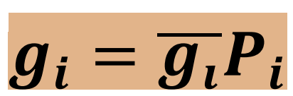
  - g_{i} conductance per unit area of membrane due to a set of ion channels of type i
  - g_{i}__ maximal conductance: conductance of an open channel times the density of channels in the membrane
  - P_{i} fraction of open channels that are open at that time

Persistent conductances
- Voltage dependent channels that are open and close as a function of membrane potential are divided in two different types depending on the conductances
  - Gating of persistent conductance: persistent current are controlled by an activation gate
  - Gating of a transient conductance: transient currents are controlled by an activation gate and an inactivation gate

- The persistent conductances channels are described by a swing gate that can open or close the pore channel
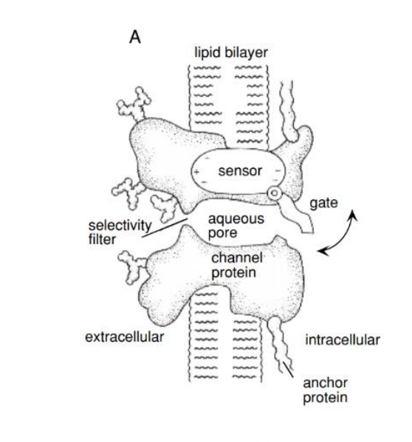

- The probability that a gate is open P_{K} increases when the neuron is depolarized and decreases when it is hyperpolarized. The opening of the gate that describes a persistent conductance may involve a number of conformational changes. If k independent identical events are required for a channel to open P_{K} can be written as P_{K} = n^{k}
- n^{K} probability that anyone of k independent gating events has occurred. Ranges between 0 and 1, is called gating variable
- k: integer chosen to fit the data, should be interpreted as a functional of a subunit. k = 4

Rate at which the open probability for a subunit gate change:
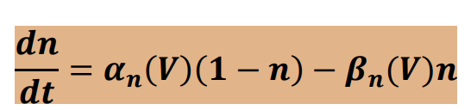
- α_{n}: rate at which closed gate opens. Occurs at voltage-dependent rate α_{n}(V)
- 1-n: probability that gate is currently closed
- β_{n}: rate at which open gate close. Occurs at voltage-dependent rate β_{n}(V)
- n: probability that gate is currently open

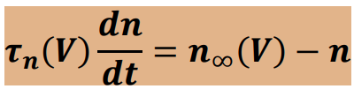
- 𝜏_{n}(V): time constant for the change in n ⟹ how quickly the probability of the gate being open can respond to changes in voltage. Smaller time constant ⟹ faster rate
- n_{inf}(V): steady rate value of n at a given membrane potential V, the probability gate will open given a constant membrane potential

!Hodgkin-Huxley model
- Model for generation of AP.
- 3 equations
- In its single compartment form is described by writing the membrane current in equation

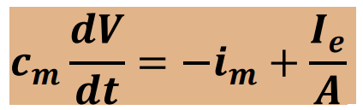as the sum of a leakage current, a persistent (only n) K+ and a transient (h, m) Na+ current:
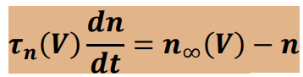

Modelling channels
- Models of single channels: indicate the states that the channel can assume
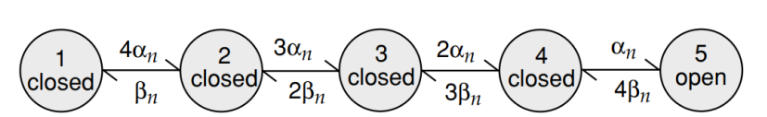
Potassium channels have 4 subunits, each subunit has a gate which can be open or closed. Potassium can flow only at stage 5 where all four gates of the four subunits are open.

- α_{n} and β_{n} in the transition rate are voltage-dependent rate functions of the Hodgkin-Huxley model
- Transition rate from state 1 to state 2 is 4 times faster than the rate from state 4 to state 5. This is because any one of the four subunit gates can open to get from state 1 to state 2, but the transaction from state 4 to state 5 requires the single remaining closed subunit gate to be open.

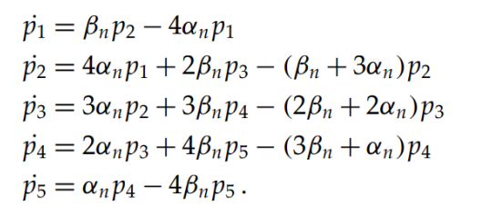
- p_{a} probability that a channel is in the state a. It is equal to the entry state in a from other states minus the rate for leaving the state a.

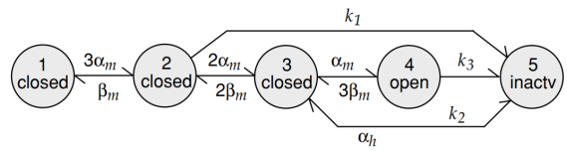
- Model of Sodium Na⁺
- Activation and inactivation process are assumed to act independently ⟹ incorrect assumption
- As the number of channel increase the HH model provides a fairly accurate description of the current

Synaptic conductances
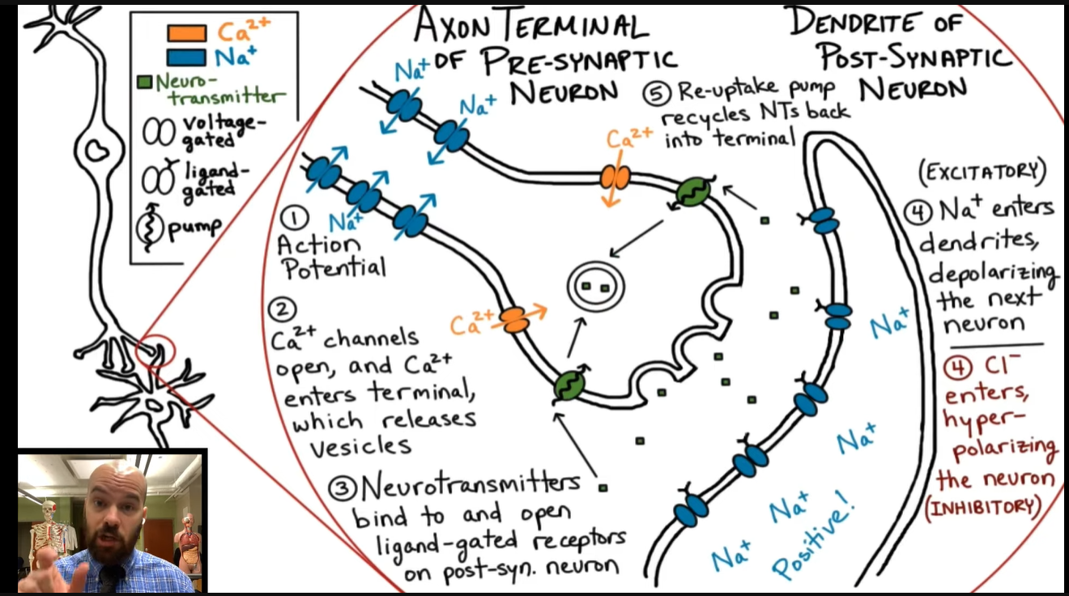
- Synaptic transmission when AP invades presynaptic terminal and activates voltage-dependent Ca channels, leading to rise in concentration of Ca2+ within the terminal.
- This causes vesicles containing transmitter molecules to fuse with the cell membrane and release their contents into the synaptic cleft between pre and postsynaptic sides of synapse.
- Transmitters diffuse across the cleft and are captured by receptors on the postsynaptic neuron.
- Binding of transmitter leads to opening of ion channels that modify conductance of postsynaptic neuron, completing transmission of signal from one neuron to other.
- Synaptic conductance written as product of maximal conductance and open channel probability:
- 
- Open prob for synaptic conductance can be expressed as product of two terms that reflect processes occurring pre and postsynaptic sides of synapse:
- 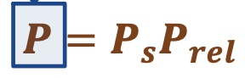
- Ps = prob that postsynaptic channel opens, given that transmitter released by presynaptic terminal.
- P rel = prob that transmitter released by presynaptic terminal following an AP. Transmitter release = stochastic process (not necessarily occurs with AP, even spontaneous release). Can be seen as average of release probabilities at each release site.
- Two broad synaptic conductances:
- Ionotropic → transmitter binds to synaptic channel and activates it directly (more rapid).
- Metabotropic → binds to distinct receptor that activates conductance indirectly through intracellular signaling pathway, long lasting changes.
- Glutamate and GABA → major excitatory and inhibitory transmitters in brain. Both act ionotropically and metabotropically.
- Principal ionotropic receptor types for glutamate: AMPA and NMDA → produce mixed cation conductances with reversal potentials around 0 mV. NMDA slower to activate and deactivate, dependent of Ca.
- GABA activates two important inhibitory synaptic conductances (receptors):
- GABA A: receptors produce fast ionotropic Cl- conductance
- GABA B: receptors metabotropic and produce longer and lasting K+ conductance.
- Neurons can be coupled through electrical synapses (gap junctions) that produce synaptic current proportional to difference between pre and post synaptic membrane potentials.

Postsynaptic conductance

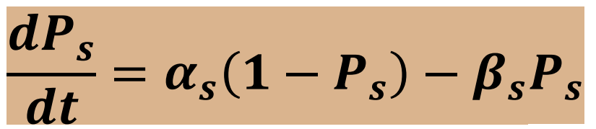
Formula of the open probability P_{s}

- Transmitter-channel binding reaction
- When an action potential invades the presynaptic terminal the transmitter concentration rises and α_{n} grows rapidly causing P_{S} to increase
- After the release of the transmitter we have a rapid reduction of the transmitter concentration, this set α_{s} to 0 and P_{s} start decaying exponentially with a time constant 1/ β_{s}
- We assume transmitter concentration in synaptic cleft rises extremely rapidly after the vesicle release, remains high value for period T and then falls rapidly to 0, the transmitter concentration is modeled as a square pulse of duration T

NMDA receptor conductance
- Additional dependence on postsynaptic potential:
- 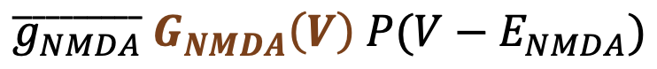
- This factor becomes new element in defining NMDA current generating postsynaptic neuron. It depends on V and on concentration of M g.
- Important to modify strength of synapses (plasticity)
- Possible to capture capability of this NMDA channel to detect pre and post synaptic activity → Hebbian rule: if more neurons work together, possible to increase synaptic strength.
- NMDA channel with strong dependency on postsynaptic potential, able to detect coincidences of activity and the modulate strength of synapses.

Release probability and short term plasticity
- Synapses not static, there are short and long terms.
- Probability of transmitter release and magnitude of resulting conductance change in postsynaptic neuron.

- Short term modification described by Prel and models of facilitation and depression differ in how release prob is changed by presynaptic activity.
- Short term facilitation: first increase rapidly and then decrease gradually
- 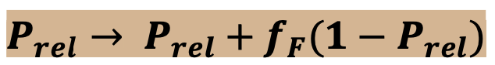
- fF controls degree of facilitation, 1-Prel prevents release prob from growing > 1.
- Short term depression: first increase gradually then decrease rapidly
- 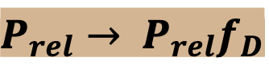
- fD controls amount of depression
- Prel prevents release prob from becoming < 0
- If we reduce Prel we decrease conductance of our synapse (less current), if we rise Prel, we are increasing conductance of synapse (more current).

